**Identifying Planning Opportunities in a Client’s 1040**

© 2016 Greene Consulting Associates, LLC INTENDED SOLELY FOR USE BY REGISTERED USERS NOT TO BE REPRODUCED OR CIRCULATED

## ABOUT GREENE CONSULTING ASSOCIATES, LLC

Greene Consulting Associates was founded in 1979 and provides consulting and training services solely to the financial services marketplace. Located in Atlanta, Georgia, Greene Consulting has worked with the top providers of investment management and wealth management in both the United States and abroad. Focused on helping firms generate incremental revenue growth through more effective sales and relationship management strategies, Greene Consulting offers customized training programs in Financial Services Sales, a Sales Management program, Presentation Training that integrates proprietary products, and a comprehensive suite of online learning courses related to investments and wealth management.

For more information about Greene Consulting or any of its products and services, write Greene Consulting at Waterstone Building, 4751 Best Road, Suite 450, Atlanta, Georgia 30337. Or, visit the company's website at [www.greeneconsults.com](http://www.greeneconsults.com).

## 

## Table of Contents

Introduction

The U.S. Individual Income Tax Return

Identifying Family Needs

Income Section

Compensation

Learning about the Client’s Investments

Identifying Investment Management Needs and Solutions

Business Income

Capital Gains

Net Investment Income Tax (NIIT)

Retirement Income

Rental Income, Royalties, Partnerships, S Corporations, Trusts, etc.

Other Income

Above the Line Deductions

Below the Line Deductions

Taxes and Credits

Alternative Minimum Tax

Cash Flow and Payment of Taxes

Two-Year Comparison

Conclusion

## Introduction

In your day-to-day business, you routinely have the opportunity to see a client or prospect’s individual income tax return – sometimes in the estate planning process, or the credit application process, or in association with a trust account. When you get the chance to see these returns, what information about your client can you glean from them in a fairly short amount of time without becoming a CPA or earning a Master’s Degree in Tax? Having gleaned that information, how can you use it to identify potential needs and solutions for your client? These are the questions that are answered by this course.

**Adobe Reader**

This lesson provides printable copies of Form 1040 and supporting schedules. To get the most from this course, you will need to view and print these forms. These files may be viewed and printed with Adobe Reader. If you do not have Adobe Reader, it may be downloaded free of charge by clicking the following link: <http://www.adobe.com/products/acrobat/readstep2.html>.

|  |
| --- |
| Objective  By studying this course, you will learn:   * How to use a client’s federal income tax return to identify potential needs and solutions * Specific lines on the return and attached forms where you should mine for information * Questions you should ask to get additional information * Open-ended questions to ask that will help clients identify their needs and motivate them to action |

|  |
| --- |
| **Course Development Partner**  This course was developed by Greene Consulting Associates, LLC in partnership with Diane Winland, whose accounting degree, CPA license, and MBA are a perfect backdrop for her experience in tax and financial planning. She spent 12 years in public accounting providing personal tax and financial planning advice to busy executives of multinational firms. Her previous experience includes working for PricewaterhouseCoopers, LLP. Diane currently works for Bank of America and consults with clients about alternative investments, estate planning issues, stock option analysis and retirement funding alternatives. |

## The U.S. Individual Income Tax Return

Below is a copy of the U.S. Individual Income Tax Return. Take a few minutes to orient yourself with this return, since it will dictate the structure of this course. Our approach will be to closely look at each section of this form to explore the new planning opportunities it reveals. It may be helpful for you to print out a copy of the complete return, which can be obtained by clicking here.

After you have had a chance to familiarize yourself with the form, we will begin the process of showing how an individual's tax return can give you far more important information that just the client's income. **Scroll through the document and place the cursor on each highlighted area to view the name of that section.**

|  |  |
| --- | --- |
| 2015 Form 1040-Page 1 - US Indiv Tax Ret | 2015 Form 1040-Page 2 - US Indiv Tax Ret |

|  |  |  |
| --- | --- | --- |
| **Front** |  | **Back** |

|  |
| --- |
| **1. Gross Income** |

|  |
| --- |
| **2. Adjusted Gross Income (AGI)** |

|  |
| --- |
| **3. Taxable Income** |

|  |
| --- |
| **4. Tentative Tax** |

|  |
| --- |
| **5. Income Tax Liability** |

## Identifying Family Needs

The beginning section of Form 1040 is often overlooked, since it contains no financial data. However, this is the section that identifies the members of the client’s household. You can use this information to stimulate further discussion with the client, which may reveal a number of new planning needs you previously didn’t see. **Click the numbered areas to learn more.**

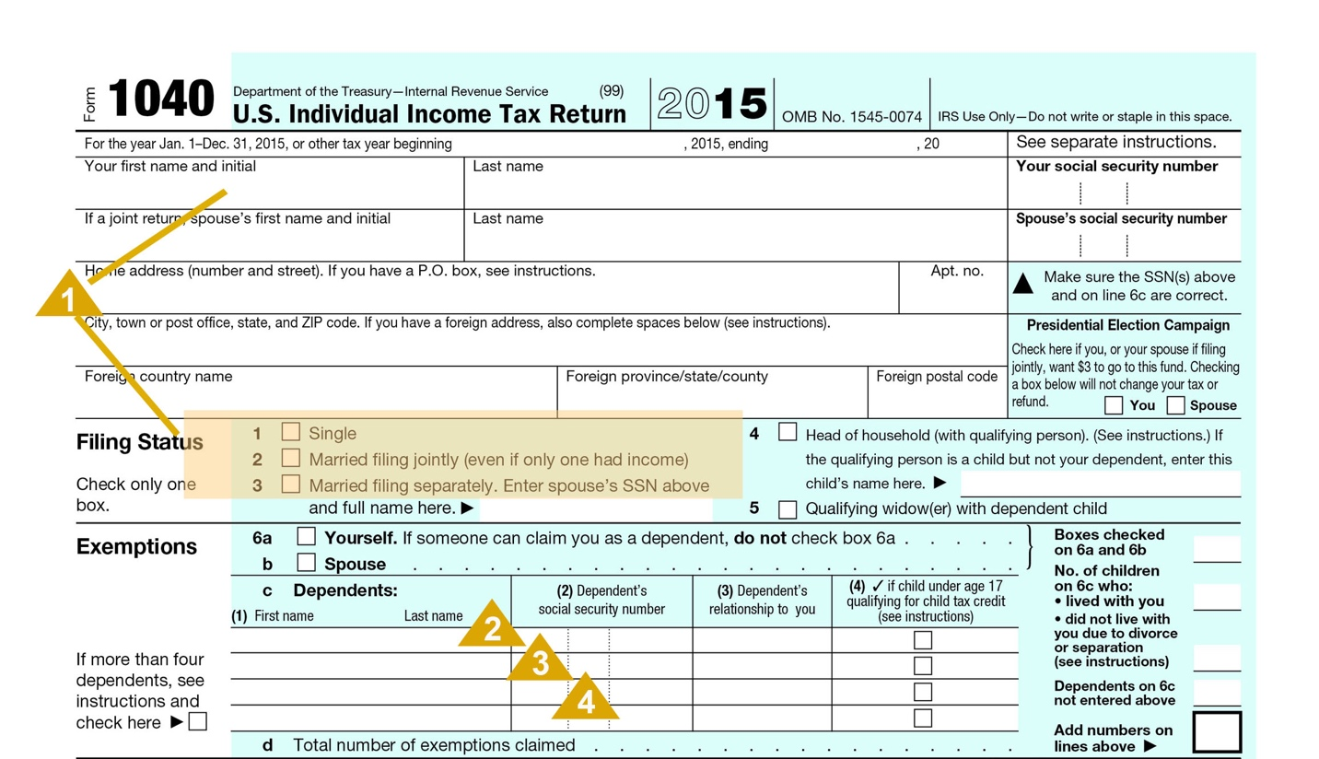

|  |
| --- |
| **1 – The Spouse**  If the client is married, the spouse’s name will appear on the tax return even if the couple does not file a “joint” income tax return. If a couple files “Married Filing Separately,” what is the reason? Does the spouse work? Does the spouse take part in the investment decisions? Etc. |

|  |
| --- |
| **2 – Dependent Children**  Dependent children will be listed on line 6c. Since most people are interested in talking about their children, it provides a great opportunity to ask some open-ended questions about the children, their ages, and their activities. This discussion will give you a better feel for the lifestyle your client leads and may reveal day-to-day situations for which the client needs assistance. Potential needs to explore include:   * Educational savings for clients with younger children. If there is a former marriage, are there binding obligations regarding the child’s care and education? If the children are approaching or are at college age, what are their plans to cover these expenses? Have they utilized ESA or 529 plans? Do they have “Kiddie Tax” issues? * General banking services for older children, such as checking accounts, credit cards, and even mortgages and investment management accounts. * Does the child have any special care needs? This can be a very significant family, financial and emotional issue that they will often be very willing to talk about. You will want to know the extent of past, present and potential future financial obligations. What financial and support resources are available, and which have they utilized? Are your clients managing their situation or are they just reacting to it? Keep in mind that this may be a financial obligation for the rest of the parents’ lives.   Parents with special needs children will often be quite knowledgeable about financial issues regarding special needs children and will usually be members of a variety of special needs support groups. Make sure that they are connected to a special needs attorney to assist them in public assistance, legal, tax and estate planning issues. Substantial estate planning needs will exist and probably abnormally high life insurance needs. Note that as a Financial Professional, there is opportunity here to develop special expertise for these parents who invariably know many other parents in similar, specialized circumstances. Certain Financial Professionals would do well to develop some understanding of the issues involving special needs children and develop a network of other professionals with specialized experience in this area. |

|  |
| --- |
| **3 – Dependent Parents**  If a dependent is a parent, there are other issues the client may be facing.   * To what degree is and will the parent be financially dependent? * Are there significant current or future medical expenses that are of a concern to the client? How will these expenses be covered? Is there potential for Medigap and/or Long-Term Care Insurance? * Does the parent require in-home assistance? If so, is the client in compliance with payroll and tax reporting rules? * Does your client have a relationship with an elder care attorney? If not, you have the opportunity to make the introduction. * Does the parent own life insurance that needs to be reviewed? Are beneficiary arrangements of policies and/or any retirement plans efficient? * Will an Assisted Care Facility, Continuing Care Retirement Community or Nursing Home need to be considered in the future? * Is there a need for estate planning or elder care expertise? Are will(s) up-to-date? Is a living trust in order? Has the parent(s) executed a Health Care Proxy and Durable Power of Attorney? Does your client have a relationship with an estate planning attorney (may also be elder care attorney)? If not, you have the opportunity to make the introduction. |

|  |
| --- |
| **4 – Other Dependents**  If children have different last names than parents, there may be a remarriage with possible financial obligations or implications. Sometimes, the dependent named on the return may not be a member of the immediate family. For example, the dependent may be a grandchild or a niece or nephew. The specific situation will dictate what other questions are asked. If possible, helpful information to obtain includes:   * Is the dependent related to the client? If so, what is the relationship? * Is the inclusion of this individual in the household a permanent situation? * What is the age of the dependent and what special considerations are there? Take care in this area, as it, too, can raise some uncomfortable feelings. * What current and potential financial obligations does your client have for this dependent? |

## Income Section

The next section of the tax return captures the gross income. Within this section, there are seven key areas in which you should focus your attention. These areas will be discussed in more detail on the following pages. **Click each topic below to view the seven key areas on the tax return.**

# Income Section - with Highlights

## Compensation

The taxpayer’s wages and salary is found on line 7 of the tax return. While this item appears on a single line, the taxpayer’s compensation is far from one-dimensional. An individual or couple may have salaries from more than one source. In addition, the wage amount on Line 7 could include regular salary, bonus amounts, stock option income, commission income, special pay allowances, and deferred income. Each of these various types of income brings with it an ability to plan and help the client. How do you discern these things?

To gain more insight into the client’s compensation, go to the attached W-2 Wage and Tax Statement. It may provide additional detail on the client’s compensation and help you identify additional opportunities. Of particular interest is Box 12, which may have one or more entries consisting of a letter followed by a dollar amount. **Click the highlighted areas on the W-2 for more information.**

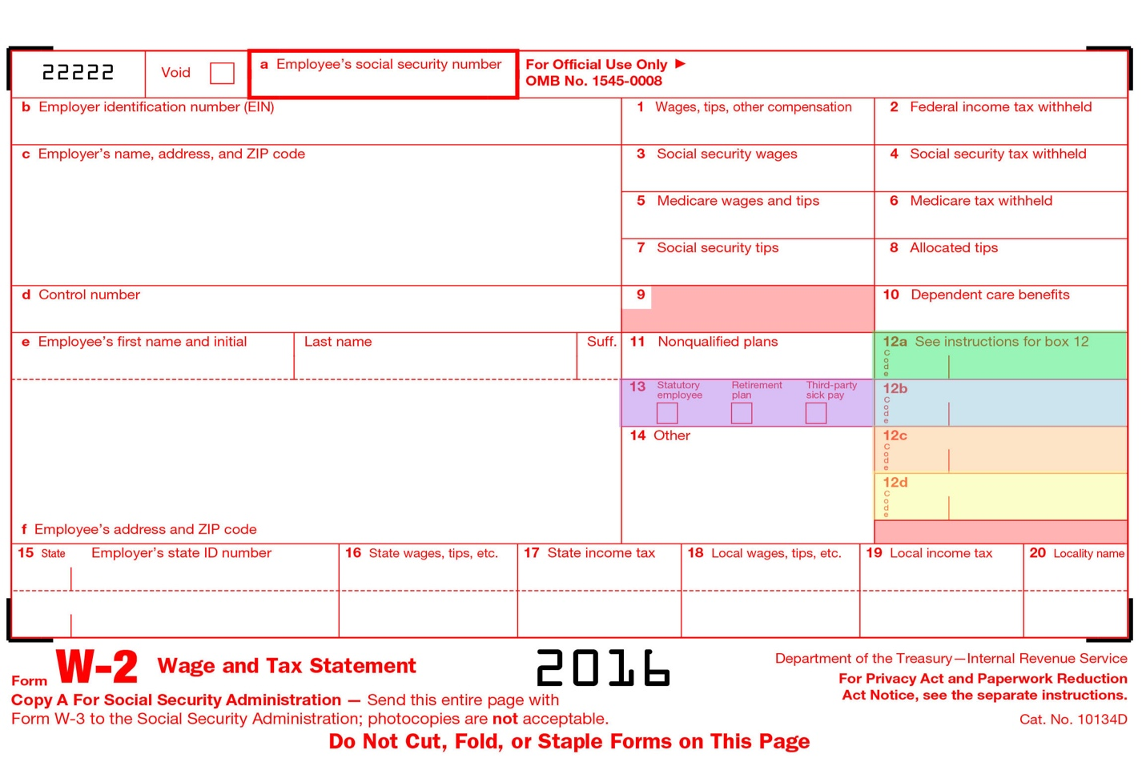

|  |
| --- |
| **12a – Insurance Planning**  This represents the cost of group term life insurance for coverage beyond $50,000. Further questions about this policy and others held by the client may help reveal the need for additional life insurance coverage. |

|  |
| --- |
| **12b – Retirement Planning**  These represent elective deferrals to various retirement plans. Typically, you will see the letter D, which is associated with 401(k) plans. This information gives you added insight into how aggressively the person is saving for retirement. If you see modest or no entries, then further inquiry on how the client is planning for retirement may reveal the need for additional assistance and/or guidance. You might begin the conversation by asking, “How are you maximizing tax-advantaged opportunities to defer income and save for retirement?” |

|  |
| --- |
| **12c – Education, Insurance and Estate Planning**  This represents benefits that the employer paid under an **adoption assistance program**. Its presence represents a significant life event for the client and, particularly if this is a first child, may open up a discussion regarding the client's insurance and estate planning needs. It also creates an opportunity to discuss education planning goals your client may have. |

|  |
| --- |
| **12d – Stock Option Planning**  This represents income from the exercise of a nonqualified stock option. When these options are exercised, they typically generate a taxable event. If the client sold the stock after exercise, then the client had sufficient liquidity for the stock; but where did the balance of the cash go? Further inquiry on your part may reveal liquid funds that you could assist in investing. If the client is still holding the stock, it may represent a considerable concentration in the client’s portfolio, particularly if this represents one of several stock options. If that proves true, you may want to ask the client, “What steps have you taken to reduce the risk associated with concentrating so much of your wealth in one security?” This may provide an opportunity for you to discuss various monetization strategies and hedging strategies that are commonly utilized to reduce such risk in a portfolio. |

|  |
| --- |
| **13 – Employer contributions to a Health Savings Account**  This represents an employer's contribution to the taxpayer's HSA. This should cause the advisor to inquire how well this plan is working versus a more traditional plan, the extent of employer-provided benefits and the potential need for disability income insurance. |

## Learning about the Client’s Investments

Income from investments, in the form of interest and dividends, is found on lines 8 and 9 of the tax return. Let’s begin by examining the information to be learned in this section of the return and then examine how that information can help you identify potential investment planning opportunities with a client.

**Click the numbered areas to learn more.**

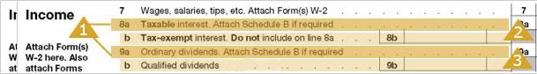

|  |  |  |
| --- | --- | --- |
| **1 – Taxable Interest and Ordinary Dividends**  The details for taxable interest and ordinary dividends will be found on Schedule B. Taxable interest (line 8a) is ***exclusive*** of tax-exempt interest (line 8b); however, ordinary dividends (line 9a) are ***inclusive*** of qualified dividends (line 9b).  There are two key questions to be answered by this Schedule. **Click numbered area on Schedule B to learn more**  scheduleb_0   |  | | --- | | **1 – What is the market value of investments?**  Using an estimated interest rate for bonds and an estimated dividend rate for stocks, it is possible to estimate the market value of each asset type.\*   * For bonds, you can use an average coupon rate for mid-term bonds. For example, the Dow Jones Corporate Bond Index will list, over the previous 5 years, an average coupon rate for 10-year corporate bonds. Assume that rate is 6.7%. By dividing the total interest on Schedule B by 6.7%, the advisor can estimate the amount of the investment. * For stocks, you can estimate the dividend rate as being from 2 to 3 percent (2.5% as an average). Simply divide the total dividends by the estimated rate to derive the estimate of the amount invested.   **Example:** If Schedule B shows interest income of $28,000 and dividends of $15,000, then the estimated value of these investments are:  Estimated bond investment = $28,000 / .067 = $418,000  Estimated stock investment = $15,000 /.025 = $600,000  *\* Estimating the value of a client’s portfolio via Schedule B does not substitute for documented information from the client. It can, however, give us a quick insight into the client’s financial position, as a check and balance to the information provided by the client, and could flag asset sales subsequent to the last tax year.* |  |  | | --- | | **2 – Where are the assets invested?**  A review of the Schedule B will reveal the payers of the interest and dividends. Sometimes, this Schedule will list each individual security. However, since financial institutions will mail out a single 1099 to provide the interest and dividends for an entire account, ***it is more common to see the name of the institution where the assets are held***. This is particularly valuable information, as it identifies your current competition. | |

|  |
| --- |
| **2 – Tax-Exempt Interest**  The taxpayer is not required to provide details of tax-exempt interest. Therefore, line 8b may be the only information you will find regarding tax-exempt interest.  As with taxable interest and dividends, we can also estimate the value of the underlying assets. Typically, the rate for mid-term AAA rated municipal bonds should be used. April 2014, 10-year municipal bonds had a yield of approximately 2%.  **Example**: If line 8b indicates $5,000 of tax-exempt interest, then the estimated value of the investment is: Estimated tax-free investments = $5,000 / .02 = $250,000 |

|  |
| --- |
| **3 – Qualified Dividends**  The dividends paid on most stocks, when properly held, qualify for a special tax rate. Line 9b will give an indication of those dividends that qualify for this reduced rate. The current difference in rates is 20%, which is quite significant.  Review the ratio of qualified dividends to ordinary dividends. If qualified dividends are low relative to ordinary dividends, this could be a sign of excessive sales in the account, which prevents stocks from being held long enough to qualify for the special rate. However, do not jump to that conclusion because there may be other explanations, such as the fact that preferred dividends are not eligible for qualified dividend treatment. |



## Identifying Investment Management Needs and Solutions

Based on the information you gather on the interest and dividend section of the tax return, it is possible to identify a preliminary asset allocation. For example, on the previous page we provide illustrations for bonds and stocks that would provide the preliminary asset allocation (below).

|  |  |  |
| --- | --- | --- |
| **Taxable Bonds** | $466,667 | 39% |
| **Tax-free Bonds** | $125,000 | 11% |
| **Stocks** | $600,000 | 50% |

As we continue through the return, we will point out other sections of the return that will provide additional information regarding investments.

Altogether, this investment information will provide you with sufficient information to initiate an informed investment discussion with the client. During the course of that discussion, you can ask fact-finding questions that will clarify your understanding and help you determine potential needs. You will also have opportunities to ask open-ended questions that help increase awareness about his or her current situation, thereby helping the client see the shortcomings that you find in the current portfolio and foster interest in solutions you can offer.

Here are some key questions to consider asking. Note that we have deliberately positioned some of these questions to place responsibility on the current advisor, rather than running the risk of embarrassing the client. **Click the icon next to each question to see the answer.**

|  |  |  |
| --- | --- | --- |
| DocumentationIcon_32px | **What are your goals for your investments?** | |
|  | **Answer:** This question opens up a general discussion of the investment portfolio, allowing you to gain insight into the client’s needs, objectives, and concerns, while also allowing you to ask further fact-finding questions like:   * What are your short-term and long-term financial needs? * How much income must your investments generate to meet your current needs? * What are some of the specific holdings in your portfolio? * How were these investments selected? * How concerned would you be if the market value of your investments declined 10% over the course of a year? 20%? 30%? * How satisfied are you with your current investment advisor? How do you make that assessment?   This discussion will generally shed light on whether or not the invested assets are properly allocated, adequately diversified, and at the proper level of risk. As these situations present themselves, you can further develop the conversation by asking some questions that increase awareness such as:   * How has your advisor worked with you to establish clearly-defined investment objectives? * How has your advisor worked with you to select investments that are appropriate for your objectives?   Such awareness questions will help the client recognize a need and incline the client to be receptive to the solutions you deem appropriate. | |
| DocumentationIcon_32px | **How has your current advisor worked with you to identify the proper asset allocation for your portfolio?** | |
|  | | **Answer:** As you learn more about the client’s needs and objectives, it may become apparent that the asset allocation is inappropriate. This is an excellent awareness question by which you can introduce a discussion regarding asset allocation. | |
| DocumentationIcon_32px | | **How has your advisor worked with you to maximize after-tax returns?** | |
|  | **Answer:** Municipal bonds generally yield an interest rate below corporate bond rates. Yet, due to the tax-free nature of many of these bonds, tax savings can at times more than compensate for the lost yield. If a client is in a lower tax bracket, but holding municipal bonds, then the client is not being adequately compensated for the lower yield. Similarly, if a client is in a higher tax bracket, but holding taxable bonds, then the client’s after-tax income can be increased through a shift to municipal bonds.  To identify what is appropriate for your client, you need to know the client’s marginal tax rate. This can be found by looking at the back of Form 1040 to find the client’s taxable income and then locating that income on a tax rate schedule.  **Example** - Upon examining the 2016 return of a married couple filing jointly, you learn that the taxable income is $250,000. Locating this income on the following rate table reveals that the federal marginal bracket is 33%.   |  |  | | --- | --- | | **If Taxable Income Is:** | **The Tax Is:** | | Not over $18,550 | 10% of the taxable income | | Over $18,550 but not over $75,300 | $1,855 plus $15% of the excess over $18,550 | | Over $75,300 but not over $151,900 | $10,367.50 plus 25% of the excess over $75,300 | | Over $151,900 but not over $231,450 | $29,517.50 plus 28% of the excess over $151,900 | | Over $231,450 but not over $413,350 | $51,791.50 plus 33% of the excess over $231,450 | | Over $413,350 but not over $466,950 | $111,818.50 plus 35% of the excess over $413,350 | | Over $466,950 | $130,578.50 plus 39.6% of the excess over $466,950 |   By analyzing the after-tax return of taxable and tax-free investments at a 33% marginal bracket, you can make the determination as to whether a shift in the bond portfolio is appropriate and whether or not this awareness question should be asked. | |
| DocumentationIcon_32px | **What process does your advisor use to select securities for your portfolio?** | |
|  | **Answer:** Often, you will discover that there is no clear process at work in selecting (or selling) securities. If so, this is a good question to ask. | |
| DocumentationIcon_32px | **How has your advisor worked with you to ensure your portfolio is appropriately diversified?** | |
|  | It is quite common to find inadequate diversification in an account. When you do, be sure to ask this question. | |

## Business Income

Business income is reported on line 12 of Form 1040.

18-bankingopp

The business income detail can be found on Schedule C, a copy of which is below.

|  |  |
| --- | --- |
|  |  |

|  |  |
| --- | --- |
| Front | Back |

For our purposes, do not be overly concerned with understanding everything you see on Schedule C. Think of it is a place where you can identify what the client is interested in or what the client is familiar with. People generally like to talk about themselves, particularly if they enjoy their profession. These discussions can help create a common ground between you and the client.

As you review the schedule, here are some questions to keep in mind. **Click the icon next to each question to see the answer.**

|  |  |
| --- | --- |
| DocumentationIcon_32px | **How aggressive is the person with deducting expenses?** |
|  | **Answer**: Take a closer look at the expenses in Part II of the Schedule. In particular, look at the ratio of expenses to income. Some business owners can be extremely aggressive in finding expenses that can be deducted. If this ratio is high, then you can be pretty sure that the client will be equally aggressive regarding investments. |
| DocumentationIcon_32px | **Are there capital needs?** |
|  | **Answer:** Inquire as to the growth of the business and its capital needs. There may be lending opportunities if the business needs capital for expansion. |
| DocumentationIcon_32px | **Are there estate planning needs?** |
|  | **Answer:** Small businesses generally present important estate planning considerations, such as:   * Has the client thought about an exit plan for the business? * Is there a succession plan that involves a child or a partner?   Are there life and health insurance needs related to the business? |

## Capital Gains

The information in the capital gain section reflects sales of assets. The important pieces of information in this section are reported on Schedule D, a copy of which can be viewed here:

|  |  |
| --- | --- |
|  |  |

In reviewing this schedule, you should be more concerned with why the assets were sold rather than what was sold or when the sale occurred. In particular, you can answer these two questions by examining Schedule D.

17-capitalgain

**Click the icon next to each question to see the answer.**

|  |  |
| --- | --- |
| DocumentationIcon_32px | **How long were assets held prior to sale?** |
|  | **Answer:** A large volume of short-term sales could indicate an aggressive investment posture. They could also indicate excessive trading on the part of an investment manager. You might further explore this with the client by asking, “How has your advisor concluded it is in your best interest to have a short-term investment strategy?” |
| DocumentationIcon_32px | **Was there a large liquidity event in the client’s life?** |
|  | **Answer:** For example, you may see that the client sold a business or that a large holding was liquidated. These events should prompt further inquiry with the client, which may reveal that the client may have additional investment needs regarding the proceeds from the sale. |

Questions that you might ask the client to gain further clarification include: **Click the icon to view example questions.**

|  |
| --- |
| **Effective Questions**   * What was the motivating factor for the sale? * Was the sale part of a structured plan? * Did the client authorize the sale or did a financial consultant have discretion in the account? * Was the portfolio being rebalanced or was the client reducing a concentrated stock position? |

These questions should lead to a discussion about Financial Planning and proper use of cash in light of goals. It could also lead very nicely into a discussion about asset choice, assumption of risk and general investment education.

*A good question to get this discussion going is,**“***How does your advisor determine when it is appropriate to sell a security?***” Chances are the client will not know the answer, which opens the door for you to position your approach.*

## Net Investment Income Tax (NIIT)

Here’s an opportunity to showcase your investment and tax expertise. Effective for 2013 and later tax years, a 3.8% tax is assessed against certain unearned income. The purpose of the tax is to provide additional funding to Medicare. Because this tax is commonly misunderstood, we present a detailed review along with suggestions for client dialog.

This tax is payable on the lesser of net investment income or adjusted gross income over the following thresholds.

|  |  |  |
| --- | --- | --- |
| **Filing Status** | **2016 AGI Threshold** | **2015 AGI Threshold** |
| **Married Filing Jointly** | $250,000 | $250,000 |
| **Married Filing Separately** | $125,000 | $125,000 |
| **Single** | $200,000 | $200,000 |

The calculation of this tax is best illustrated by example. Assume that your clients are married and file jointly. Their adjusted gross income is $400,000. Their investment income is $210,000 and they have $10,000 in investment expenses. Their net investment income tax is $5,700 calculated as follows.

|  |  |
| --- | --- |
| **Example of NIIT Calculation** | |
| **Factor** | **Amount** |
| Adjusted Gross Income | $400,000 |
| Less threshold AGI, married filing jointly (from chart above) | $250,000 |
| Excess of AGI over threshold | $150,000 |
| Net Investment Income  ($210,000-$10,000) | $200,000 |
| Lesser of excess AGI or Net Investment Income | $150,000 |
| NIIT= 3.8% of $150,000 | $5,700 |

The NIIT is assessed on IRS Form 8960.

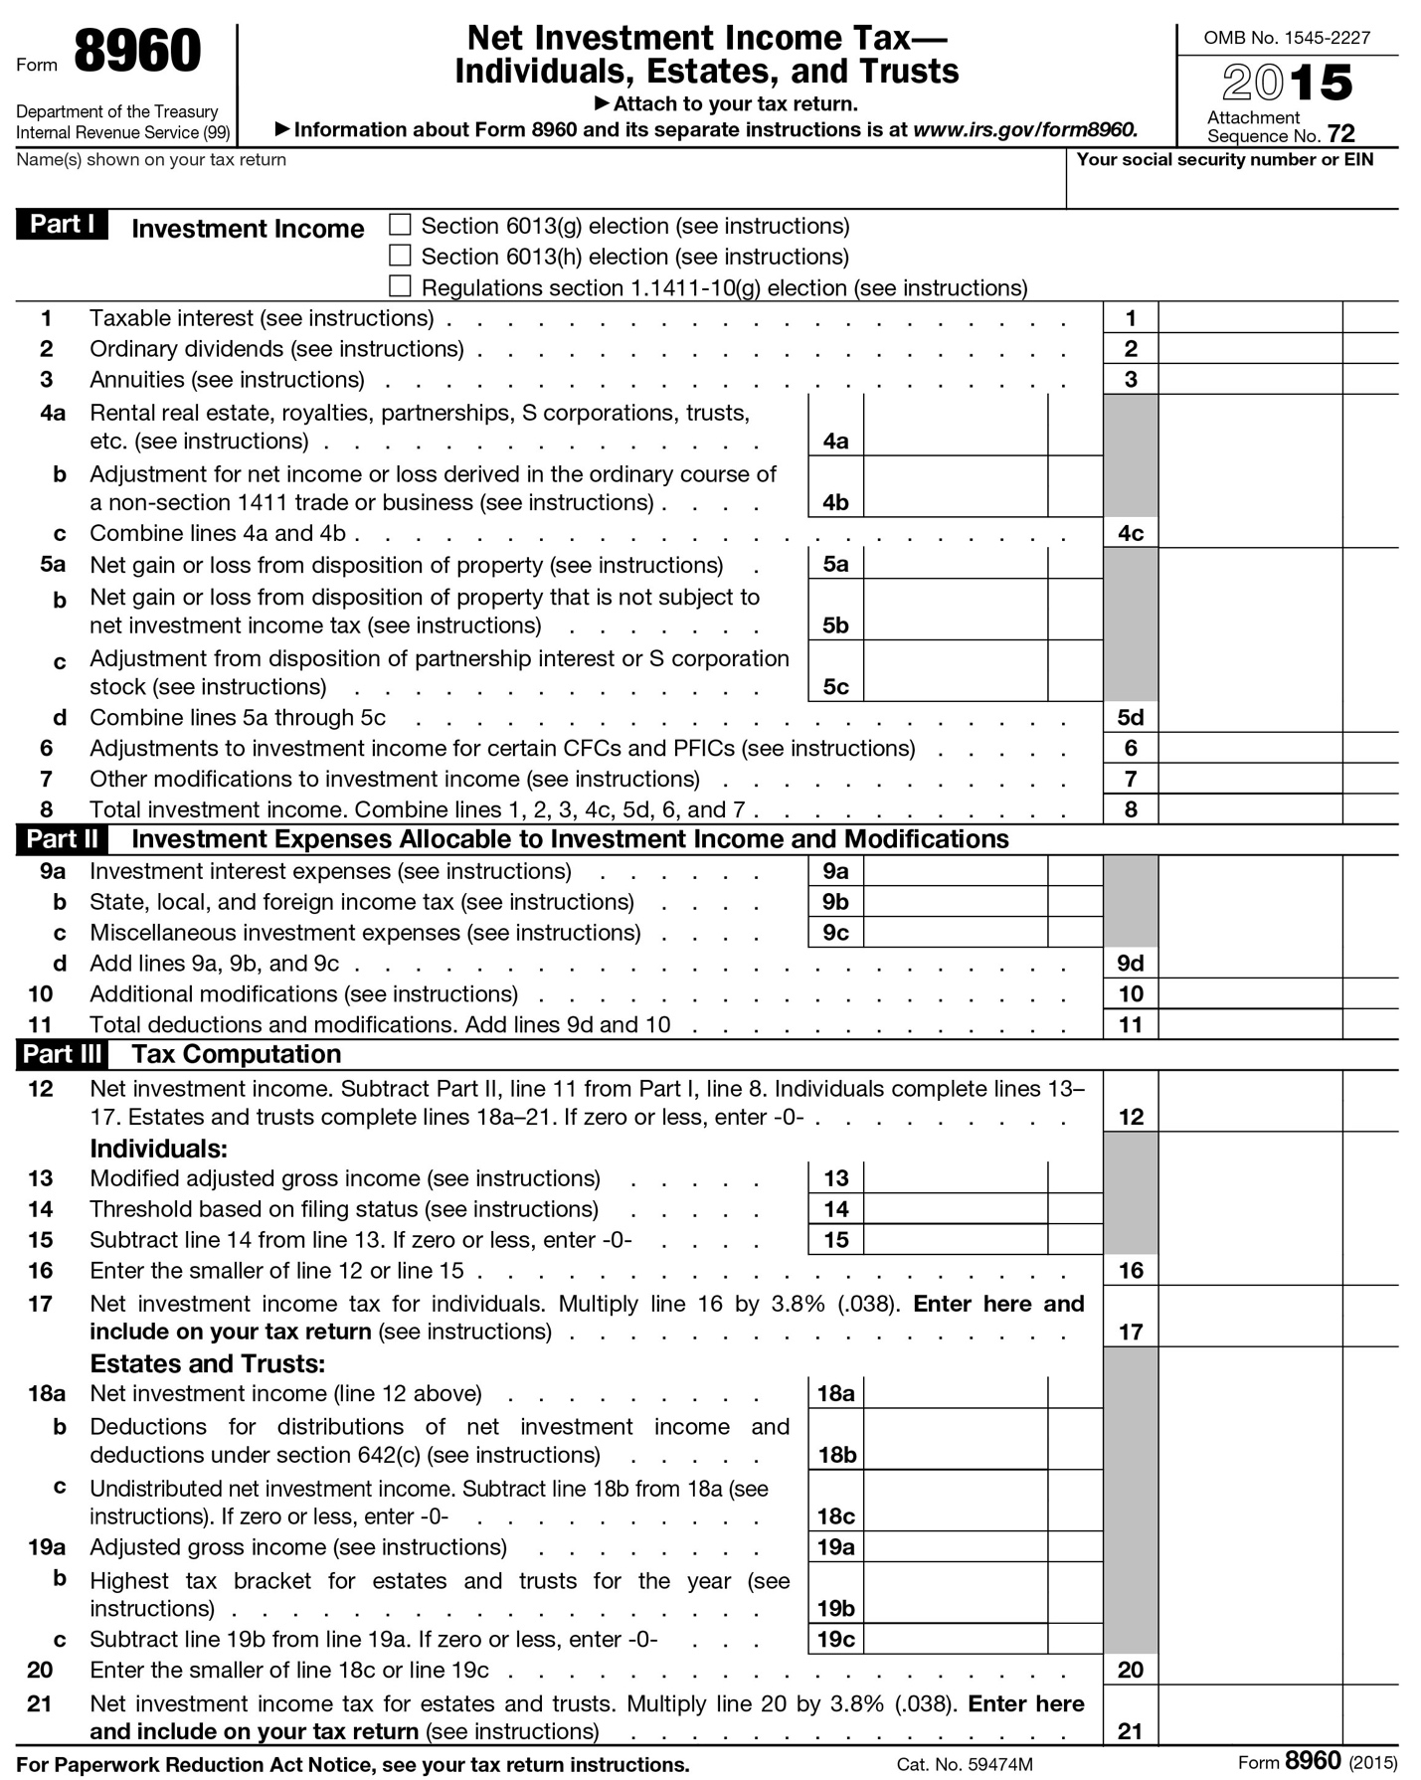

In reviewing this form, you should be focused upon helping your client understand how portfolio investment decisions affect the NIIT.

|  |
| --- |
| **Effective Question**   * How has your advisor minimized this tax in your investment strategy? |

This question should lead to a dialog around alternatives for avoiding or minimizing the tax. **Click** here **to learn more.**

|  |
| --- |
| Avoiding or Minimizing the NIIT  Tax counsel or the client’s CPA should be involved in long-term tax planning; however, you should know there are two broad approaches in managing the NIIT.   1. Restructure your client’s portfolio to avoid the NIIT  * Consider the purchase of municipal bonds because the municipal bond interest income is not subject to the NIIT * Only recognized capital gains are subject to the NIIT; hence, a “buy and hold” investment strategy, if appropriate for your client’s investment goals, will reduce the net investment income subject to the NIIT. * Charitably-inclined clients should consider gifting appreciated securities instead of cash. The gains will not be reported as investment income and your client receives an income tax deduction (generally) for the fair market value of the appreciated security. * Harvest capital losses, where appropriate, to offset capital gains. * Income from Subchapter S Corporations or Partnerships in which your client is inactive in the business is called passive income. Passive income is “investment income” for purposes of the NIIT. If appropriate, your client may wish to become active in the business to avoid the passive income. Your client should discuss this with their CPA or tax professional.  1. Minimize your client’s AGI  * Qualifying distributions from ROTH IRA, Roth 401(k), Roth 403(b), and Roth 457(b) accounts are income tax-free and NIIT-free. * Distributions from Traditional IRAs and most qualified retirement plans are not “investment income” for NIIT purposes, but these taxable distributions increase AGI. Increases to AGI above the thresholds listed above can expose your client to the NIIT.   While beyond the scope for this course, the sale of a business or investment property can incur the NIIT. In these cases, tax-deferred exchanges and/or installment sales may be considered where otherwise appropriate. |

## Income

Retirement income includes distributions from IRA plans, company sponsored plans, pension plans and Social Security. This information can be found on these highlighted lines of Form 1040.

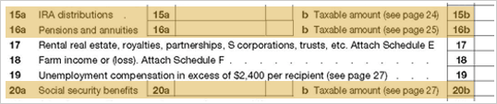

If you see entries here, then there is a potential opportunity to assist the client with retirement income planning. To discern this need, you will need to gather more facts by asking questions such as the following: **Click the icon to view example questions.**

|  |  |
| --- | --- |
| DocumentationIcon_32px | **Click the icon to view example questions.** |
| * When was retirement? * What benefits are payable in retirement? * What type of cash flow is the client expecting during retirement? * Are the current payments meeting the cash flow need? * Will the client rollover a company-sponsored plan into an IRA? * Does the client receive any other benefits that are not being paid in the current year? * Will the client have access to deferred income? * What are the plans for retirement? * Will invested assets need to produce income to supplement retirement plan payments? * Are your retirement income assets allocated to maximize your after-tax return? * Are your retirement income assets allocated in accordance with your risk tolerance? | | |

As these questions are answered, needs may surface. If so, be sure to ask good open-ended questions that will help the client question the current approach and seek resolution of the need. For example, if it appears that cash flow needs are not being met or future needs have not been planned for, you might ask:

|  |  |
| --- | --- |
| DocumentationIcon_32px | **Click the icon to view example questions.** |
| * How has your advisor structured your portfolio so that you don’t have to worry about your cash needs? * How has your advisor structured your portfolio to provide the ongoing income you need without having to resort to untimely sales of assets? * How has your advisor anticipated and planned for the cash need you will have regarding (a future anticipated event)? | | |

## Rental Income, Royalties, Partnerships, S Corporations, Trusts, etc.

Line 17 shows income from rental real estate, partnerships, S corporations, trusts, etc. The detail for these sources of income can be found on Schedule E, a copy of which can be viewed below.

20-rental

|  |  |
| --- | --- |
|  |  |

This Schedule is broken into five sections, but for our purposes you need only concern yourself with the first three sections. **Click each section to learn more.**

|  |
| --- |
| **Part I** |
| **Income or Loss from Rental Real Estate and Royalties**  **Click each numbered area to learn more.**     |  | | --- | | **1 – What, Where, and How Much?**  From Part 1 you will learn:   * The kind of property owned (e.g., a commercial building, a house, oil and gas rights, music royalties, etc.). * The location of rental property. * The amount of gross income it received.   Depending upon the assets you see, here are some questions and considerations you might wish to explore with the client:   * Is the property being held primarily to generate income or for appreciation purposes? * How is the mortgage on this property structured? You may be able to propose a better solution. * Is the client considering selling the property? If so, a tax-free exchange could be attractive to the client. * How will this piece of property be handled in the estate?” Real estate can be tricky when dividing an estate. * Does this investment fit into the overall portfolio when considering the client’s goals and needs? Often, affluent clients have a significant amount of their net worth tied up in real estate investments that can be problematic if they do not consistently review their holdings to ensure they are well diversified. |  |  | | --- | | **2 - Expenses**  These are the expenses associated with the income producing property. Aside from depreciation expense, these items generally require a cash outlay. When compared to the income generated from the property, these will give you an idea of the cash flow from the property, and whether or not there is need for cash from other sources. | |
| **Part II** |
| **Income or Loss from Partnerships and S Corporations**  **Click each numbered area to learn more.**  **20-section2**   |  | | --- | | **1 – Partnerships and S Corporations**  This section reveals any investments in partnerships and S Corporations that generated a K-1 tax reporting form. All you are interested in at this point is identifying whether or not these are part of the client’s holdings. If so, then you should recognize that these types of investments generate all sorts of issues:   * What is the nature of the business and is the client directly involved in the day-to-day business? * What is the client’s long-term intention with regard to any of the investments in this area? * How are these investments managed in context with the overall portfolio? | |
| **Part III** |
| **Income or Loss from Estates or Trusts**  **Click the numbered area to learn more.**     |  | | --- | | **1 – Estates and Trusts**  Trusts and estates also generate K-1 tax reporting to beneficiaries. If you see an estate listed, find out what assets will ultimately be distributed to the client. This may identify a need to assist the client with investing the inheritance.  If you see a trust listed, find out more about the trust.   * What are the terms of the trust? * When does the trust terminate? Some trusts have specific termination dates, which allow planning for the disbursement. * Who acts as trustee? If it is a family member, it may be appropriate to discuss the advantages and disadvantages to using a family member versus a professional to ensure the client would prefer having the family member. | |

## Other Income

The “other” income section is reported on the line on the tax return with the same name – “Other Income”.

21-otherincome

|  |  |
| --- | --- |
| **Overview** | Director’s fees and trustee fees are the two most common entries found here. Knowledge of these items will give you an idea of where the client spends time. **Click each term to learn more.** |
| **Directors** | In recent years, greater scrutiny has been focused on Boards of publicly traded companies. As such, a director is held to a higher standard of performance and an individual holding such a position will spend more time now than someone in such a position would have spent five years ago. Since these positions are more time-consuming and carry a much greater likelihood of public criticism, directors are more carefully chosen and are more thoughtful in acceptance. If a client is a current board member, it tells the consultant that the client is serious about the business affiliation and directorship duties. |
| **Trustees** | Trustee fees generally indicate a level of trust that the client enjoys within the family or close friends. Since the job of trustee is not subject to public scrutiny, it is sometimes a thankless job. Furthermore, the duties that accompany the fees are often unpleasant and can be quite time-consuming. You may be able to offer professional services to assist the client in fulfilling the trustee duties, should the client so desire.  The key to suggesting assistance is to find out how comfortable the client is with the duties that accompany the trustee title. It is also possible that the client has never seriously considered the liability associated with acting as trustee.  Begin by asking some fact-based questions. These will help you surface potential needs.   * When was the trust created? * How did the trust come about (due to death or some other event)? * Who are the beneficiaries? * What is the size of the trust? * Can the client name a successor trustee? * What does the document say about the client’s power to name a co-trustee or an investment agent?   Once you have a clearer picture of the nature of the trust, asking more open-ended, awareness questions may introduce opportunities for you to provide assistance. Consider the following examples:   * How do you feel about the risks associated with acting as trustee? * How have you balanced your desire to have close family relations against the risk that your decisions as trustee could be divisive (if the beneficiaries are family members)? |

## Above the Line Deductions

Unlike individuals in the U.S., not all deductions are created equal. Some provide much more benefit than others. The Internal Revenue Code divides deductions into two categories: those “above the line” and those “below the line.” “The line” is a magic number called ***Adjusted Gross Income (AGI)*** and it appears twice on the tax return. It is the last number on the first page and the first number on the last page. Adjusted Gross Income is used throughout the return to calculate the deductibility of expenses, the deductibility of exemptions, the calculation of tax and the application of tax credits. Generally speaking, deductions “above the line” provide more benefit than those “below the line” due to the importance of the AGI number.

What are “above the line” deductions? They are the deductions that are taken to transform Gross Income into Adjusted Gross Income. The three primary deductions of importance to us are those allowed for: (1) IRA and other retirement plan contributions; (2) self-employed health insurance payments; and (3) education expenses. **Click each numbered area to learn more.**

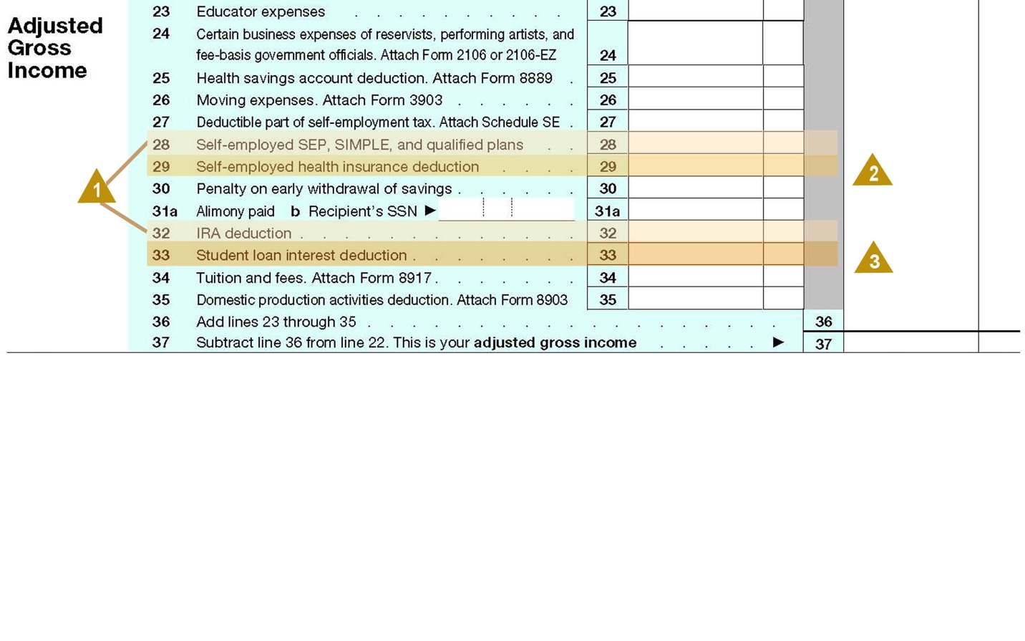

|  |
| --- |
| **1 – Retirement Planning Information**  With regard to retirement plan contributions, the client is using cash to save for retirement. You should ask about the client’s plans for retirement, timing for retirement and the need for additional savings. If the plan includes an IRA, is the client happy with the current provider? Has the asset allocation been properly adhered to in light of the stated goals? Would a rollover be appropriate to meet the client’s goals? |

|  |
| --- |
| **2 – Insurance Information**  Self-employed health insurance payments indicate the client is a business owner. This information should be included with other information on the return regarding the business, and is useful in discussing other business-related insurance needs such as life insurance and umbrella liability coverage.  The use of an Archer Savings Account indicates a tax-savvy client and offers the opportunity to ask about the current custodial services and ensure the client’s needs are being met. |

|  |
| --- |
| **3 – Education Planning Information**  A deduction for education expenses indicates that someone in the household is engaged in higher learning. Who is that person? Is a dependent, the client, or a spouse in school? Is additional funding needed for education expenses? You should discuss the various lending products that might fill a cash flow need for the client. The presence of education expenses can also lead into a discussion of future cash flow needs and plans for career changes. |

## Below the Line Deductions

What are “below the line” deductions? These are deductions most commonly referred to as itemized deductions, by which AGI is adjusted to derive taxable income. These deductions are made up of medical expenses, taxes, interest, charitable contributions, casualty losses and miscellaneous deductions. While itemized deductions are reported on a single line of the return, the details behind the deductions are shown on **Schedule A**, which shall be examined more closely below.

23-below**Scroll through the document and click on each highlighted area to view more information.**

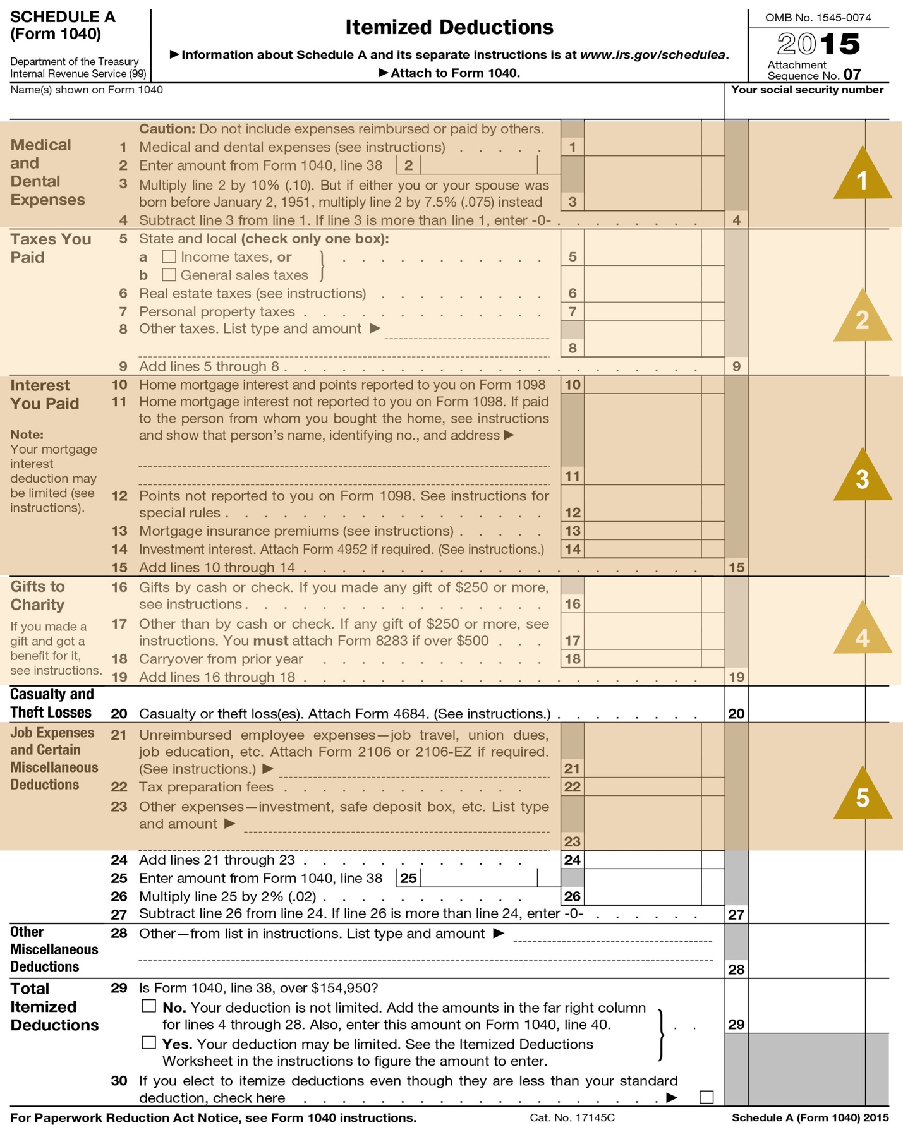

|  |
| --- |
| **1 - Medical Expenses**  It is difficult to receive a tax benefit from medical expenses due to a “floor” (costs that exceed 10% of the taxpayer's AGI) that the IRS requires before the taxpayer can deduct any of these expenses. Unless the client is paying for nursing home expenses or has experienced a catastrophic medical event, most taxpayers are unable to gain benefit from medical expenses.  Thus, an entry in this area indicates long-term medical care costs or a one-time event. Inquiry should be made to identify any possible implications regarding estate planning needs. |

|  |
| --- |
| **2 - Taxes**  Yes, taxes are deductible. Which ones? State income tax payments, real estate taxes, and personal property taxes are most common in this area. You can learn several things from this section:   * You can identify the person’s home state based on the state income tax payments. * The payment of real estate taxes indicates a possible mortgage opportunity. In fact, further discussion about what type of property is generating the real estate taxes could reveal multiple properties, such as a main home and a vacation property, all mortgage opportunities. * The presence of state income taxes serves as a reminder to consider both Federal and State taxes when examining the tax effectiveness of investments. |

|  |
| --- |
| **3 - Interest Expense**  The presence of interest expense should always lead to a discussion of mortgage products. In doing so, you should be mindful of the use of the proceeds and the ability to deduct the interest expense. Even though mortgage interest is reported on a tax return, it doesn’t mean it is always deductible. The general rules for deducting interest expense take into consideration the purpose of the loan. If the proceeds of the loan are used for personal expenses, the interest is generally not deductible. The exception to the rule is a mortgage on the main home. If the main home secures the loan, then the interest is deductible. Most people think of the exception as the general rule because they have a mortgage on their home. For details regarding the deductibility of mortgage interest, refer your client to a qualified tax advisor.  Investment interest is also reported in this section. This can lead to inquiries regarding the nature of the debt(s), the size of the debts relative to the collateral assets, the cash flow requirements, and possible restructuring of the debt. |

|  |
| --- |
| **4 - Charitable Contributions**  Charitable contributions indicate the client’s philanthropic intentions. Large deductions could lead to a discussion of the benefits of a charitable trust, a private foundation, or a community foundation as alternatives to outright gifting. Also of importance is the nature of the property being contributed.  A number of fact-finding questions are appropriate regarding this matter, some of which you can discern without even asking the question:   * Is cash being used? * Are there other assets that would serve this purpose better? * Did the client contribute more than was deductible in one year and is there a carry-forward of the benefit? * Does the client realize when the deduction provides benefits? * What are the client’s long-term intentions for charitable contributions? * Are those intentions reflected in the client’s day-to-day activities, in the portfolio of investments, and in the estate plan?   By gathering this information, you can use this topic to open a discussion regarding the next generation of a wealthy client. For example, you might ask an open-ended question like, “How do you balance your desire to make charitable contributions against your desire to leave behind an estate for your family?” The client might be surprised to find that there are techniques available to maximize the lifetime benefit of making gifts to charities (e.g., gifting appreciated property, charitable remainder trusts, etc.), while also preserving the estate for loved ones (e.g., using the proceeds from a charitable remainder trust to purchase life insurance). You should be prepared to discuss these options with the client. There are many planning opportunities for charitable contributions and the Advisor should discuss these options with the client. |

|  |
| --- |
| **5 - Miscellaneous Itemized Deductions**  Last are miscellaneous itemized deductions. The tax preparation fee and investment/trust fees are reported here. The consultant can get an idea of what the competition is billing for investment management and for trust services. You should discern the answer to the following questions:   * What do you value in your relationship with these advisors? * What changes would you make in these relationships? * How have you evaluated the fees they are charging to ensure they are competitive? |

## Taxes and Credits

The “regular” tax responsibility, along with extra taxes, is calculated in the last section of the tax return. There are some key issues to note in this section. **Click each numbered area to learn more.**

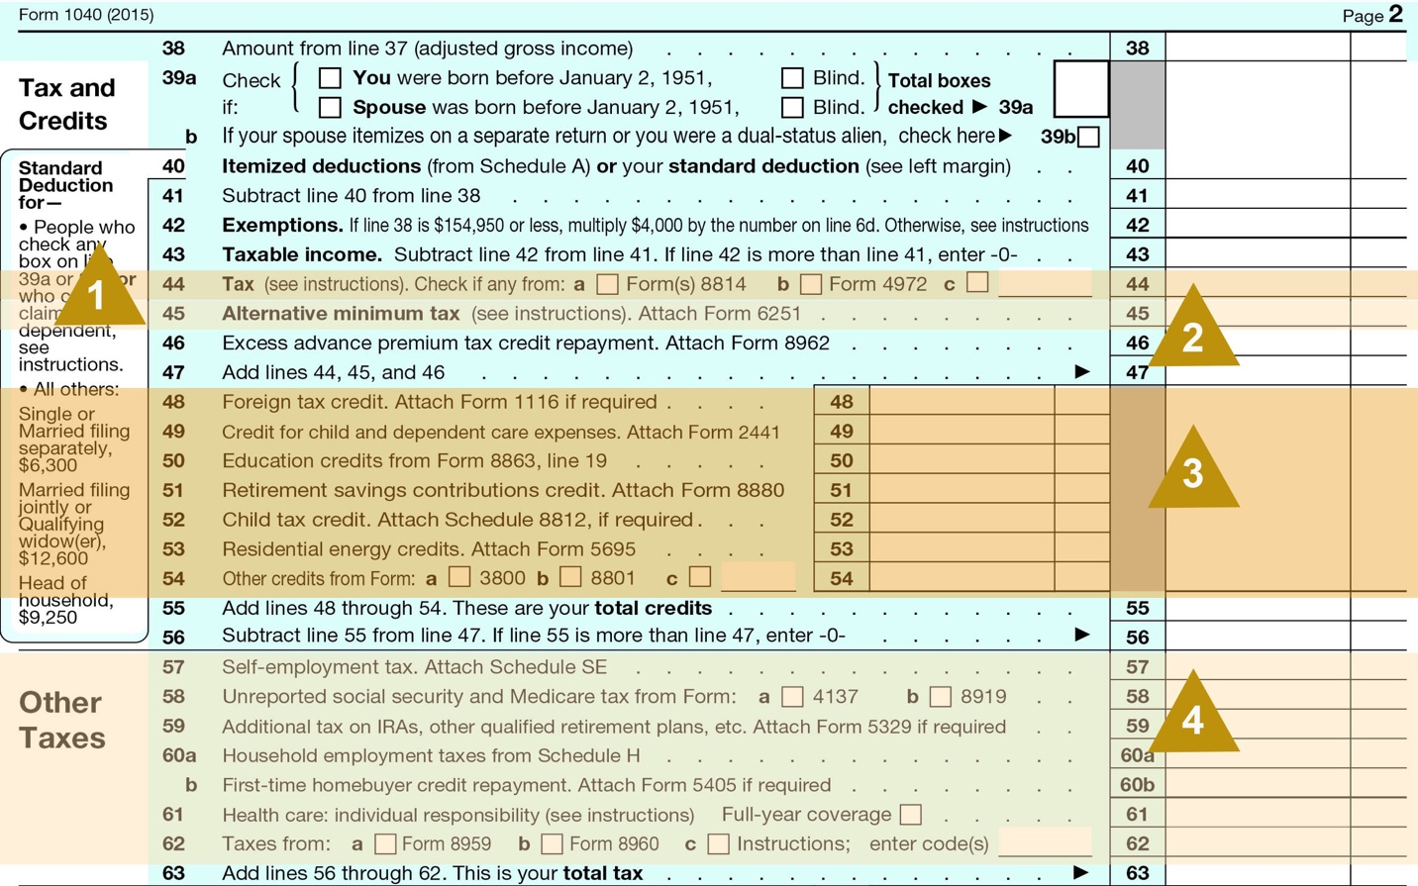

|  |
| --- |
| **1 - Regular Tax**  The **“*regular tax”*** is the tax that most people think of. It is calculated based on income less deductions and exemptions. |

|  |
| --- |
| **2 - Alternative Minimum Tax (AMT)**  Another extra tax is the ***Alternative Minimum Tax*** or ***AMT***. This tax is a misunderstood tax. It is calculated for every person filing a tax return for every year that a return is filed. Many people are unaware of this tax because it is a minimum tax, and their calculated “regular” income tax is above this minimum tax. However, once a client deducts enough expenses to cause the “regular” tax to be calculated below the minimum tax number, that client will become painfully aware of AMT.  If you see an entry on this line, then you should look for Form 6251, which will be part of the return. There are several items you should explore on that form, which will be discussed on the next page. |

|  |
| --- |
| **3 - Tax Credits** Foreign tax credits, child tax credits, dependent care credit, and education credits are the most common credits reported in this section. For our purposes here, you are most concerned with the presence of a foreign tax credit on Line 44. This is an indicator that there are international investments in the client’s portfolio. This provides additional information to help you flesh out a picture of the client’s current investments. |

|  |
| --- |
| **4 - Extra Taxes** The extra taxes are calculated based on extra items such as business income (self-employment tax) and whether or not the client employs workers like a housekeeper or a nanny. This is simply supplemental information that may be useful to know when discussing the client’s current needs. The Net Investment Income Tax (NIIT) is reported in this section. Please refer to our earlier discussion of uncovering client needs in connection with the NIIT. |

## Alternative Minimum Tax

The “regular” income tax is calculated based on a set of rules, and the AMT is calculated on another set of rules. Those two sets of rules do not match. While the rules associated with the Alternative Minimum Tax are complex and far outside of the scope of this lesson, there are several items captured on Form 6251 that are worth noting. **Click each numbered area to learn more.**

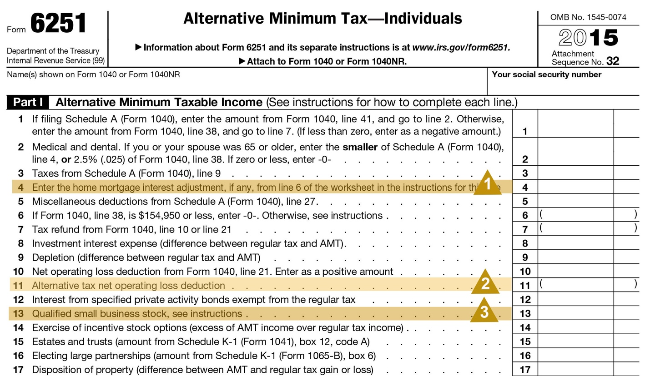

|  |
| --- |
| **1** - If the client uses the proceeds of a home equity line of credit for something other than a home improvement, the interest is not deductible for AMT purposes. Thus, the client may not be achieving the favorable after-tax rate that was expected. When you see an entry here, it may mean the client  should consider other modes of financing to see if a better after-tax rate can be achieved. |

|  |
| --- |
| **2** - Private activity bonds are special municipal bonds. While the interest from these bonds is not included in the “regular income tax,” it is included for AMT purposes. The presence of an entry on this line warrants an examination of the client’s asset allocation and consideration of alternatives that will not be included in AMT. |

|  |
| --- |
| **3** - When incentive stock options are exercised, the spread between the exercise price and the current market price is not treated as income for “regular taxes,” but it is included as income for AMT purposes. The additional tax generated can be substantial, generating a cash flow problem for the client, especially if the client wishes to hold onto the exercised securities as required by the tax rules (if they are to receive long-term capital gain treatment upon sale). Furthermore, when you see one exercise, there are likely to be additional exercises in the future.  In short, the presence of incentive stock options offers a number of potential areas the client may have needs, leading the Advisor to:   * Assist with planning and financing the exercise of options. * Provide liquidity to pay the tax. * Offer strategies by which the client can reduce the risk of holding a concentration. Many institutions offer some sophisticated planning in this regard. * Provide additional planning services once the stock concentration is ultimately liquidated.   A good open-ended question for a client who hopes to pay lower taxes by holding exercised stock for a year is to ask, “Given today’s volatile market, how have you addressed the risk of holding a large stock concentration?” Of course, like any good question, don’t ask the question without being prepared to present the solutions you can offer. |

## Cash Flow and Payment of Taxes

The IRS requires all taxes to be paid evenly or ratably throughout the year. If the client does not have a withholding mechanism that will satisfy this even payment requirement, that client will be required to make quarterly estimated tax payments. You can discover which method is being utilized by the client, and the size of those payments, by looking at the following lines (below).

2012

If the client is making estimated payments, these payments should be considered when cash flow is discussed, as many clients discount this requirement. To assist in this matter, you might be able to offer a line of credit or might propose the laddering of bonds with maturity dates in line with the payments so as to avoid selling securities to make the tax payments.

## Two-Year Comparison

Thus far, we have discussed the examination of a single tax return. However, many tax preparers and software packages offer a ***2-year comparison*** along with the tax return. If this comparison is included with the tax information you are reviewing, take note of any changes from the prior year to the current year:

* Has there been a change in the number of dependents?
* Has there been a significant change in income or deduction amounts?

These changes reflected in the tax data can mirror changes in the client’s life situation. Children may be moving out of the house, creating a situation where the client may be looking to downsize their home or add a vacation home. The client may have also added a dependent, indicating a birth or financial responsibility for a dependent. This may indicate the need for additional cash flow.

## Conclusion

This concludes this course on the client 1040. The knowledge contained herein will allow you to add greater value for your client and increase the level of service you offer in meeting the client’s needs.

**Review Guide**

We have covered a lot of material in a fairly short time and, quite possibly, you may feel a bit overwhelmed with all the things to remember. To assist you with your next review of a client’s Form 1040, we have created a Review Guide, which may be viewed and printed by clicking the icon below.

|  |  |  |
| --- | --- | --- |
| |  |  | | --- | --- | | DocumentationIcon_32px | **Click the icon to access the Review Guide.** | |

## Form 1040 Review Guide

The following guide is for use in identifying planning needs through a review of a client’s Federal Income Tax Return. The headings parallel the tax form.

|  |
| --- |
| **Filing Status** |
| **Label; Line 2 – What is the name of the spouse?** |

|  |
| --- |
| **Exemptions** |
| **Who are the dependents?**   * For children – Potential needs are educational savings, banking needs of older children, or special care needs. * For parents – Potential needs are elder care, investment management of the parent’s assets, or insurance. * For others – Needs will be specific to the situation that has created the dependency. |

|  |
| --- |
| **Income** |
| **What is the salary or compensation?**   * See if any of these codes are in boxes 12a through 12d of the attached W-2 Wage and Tax Statement:   ***C = Group term life insurance beyond $50,000.*** What other life insurance does the client have? Is it adequate?  ***D, E, F, G, H, S = Elective deferrals to various retirement plans.*** Is the client maximizing tax-advantaged opportunities to defer income and save for retirement?  ***T – Benefits paid under an adoption assistance program.*** This life-changing event opens up the possibility to discuss estate planning and education planning.  ***V –******Income from the exercise of a nonqualified stock option.*** Such sales may generate liquidity needs and/or investment management needs.  ***W -*** ***Employer contributions to a health savings account.*** Is the client maximizing the efficiency of his medical coverage? How extensive are his employee benefits? What provisions has the client made for the potential risk of disability?  **What are the client’s investments?** Examine Schedule B for details.   * From the level and type of income, estimate the value of the assets and how they are allocated. * Look at where the assets are held. This is your competition. * Is the client taking advantage of qualified dividend rates, or are assets being sold too soon? * ***Key questions to ask are:***   + What are your goals for your investments?   + How has your current advisor worked with you to identify the proper asset allocation for your investments?   + How has your advisor worked with you to maximize after-tax returns?   + What process does your advisor use to select securities for your portfolio?   + How has your advisor worked with you to ensure your investments are appropriately diversified?   **Does the client have business income?** If so, review Schedule C.   * Is the client aggressive in deducting expenses? * Are there capital needs associated with the business? * Are there estate planning needs associated with the business?   **Does the client have capital gains or losses?** Details are found on Schedule D.   * How long were assets held prior to sale? If there were a lot of short-term gains, you might ask: “How has your advisor concluded it is in your best interest to have a short-term investment strategy?” * Was there a large liquidity event? This should prompt further inquiry to reveal potential investment opportunities. * A good open-ended question to ask is, “How does your advisor determine when it is appropriate to sell a security?”   **Is the client receiving retirement and/or Social Security income?** If so, ask some fact-finding questions to discern the overall retirement plan and the client’s need for retirement income. Then ask some open-ended questions like:   * How has your advisor structured your portfolio so that you don’t have to worry about your cash needs? * How has your advisor structured your portfolio to provide the ongoing income you need without having to resort to untimely sales of assets? * Is the client receiving Social Security income for retirement benefits or for another reason?   **Does the client have income or loss from rental real estate,** **partnerships, S corporations, or trusts?** If so, ask fact-finding questions to learn more about these items and the client’s involvement with them. Key issues to discern include:   * Are there expenses associated with these that might impact the client’s cash flow? * Do these items make sense in the client’s overall portfolio? * Is the client anticipating a sizeable future distribution for which you could provide investment assistance?   **Is the client receiving any “other” income?** **?** In particular, look for trustee fees. The client may need assistance in fulfilling trustee duties or may prefer to reduce the risk associated with acting as trustee. |

|  |
| --- |
| **Adjusted Gross Income** |
| **Is the client saving for retirement?** Ask about the client’s plans for retirement, timing for retirement and the need for additional savings.   * If the plan includes an IRA, is the client happy with the current provider? * Is there a rollover opportunity?   **Is the client paying for self-employed health insurance?** If so, you should explore other potential business-related insurance needs, such as life insurance and liability coverage.  **Is there an educational deduction?** If so, there may be cash flow needs. |

|  |
| --- |
| **Tax and Credits** |
| **Did the client itemize deductions?** If so, look at Schedule A.   * Schedule A, Line 4 – Was there a deduction for medical expenses? If so, find out if this represents a one-time event or a long-term care need. * Schedule A, Lines 10 and 11 – Are there deductions for mortgage interest? If so, there may be an opportunity for refinancing. * Schedule A, Line 14 – Was there an investment interest deduction? Will the client have sufficient investment income by which to deduct interest expenses in the future? * Schedule A, Line 19 – Is the client charitably inclined? If so, examine the types of property being given, the client’s ability to maximize the current benefit of such gifts, and the long-term goals of the client. This may open up a broader discussion of various planned giving approaches. * Schedule A, Lines 22 and 23 – What are other professionals charging for their services? What levels of services are being offered and is the client happy with them? Can you better meet their needs?   **Is there an AMT tax?** If so, examine the following lines on Form 6251:   * Form 6251, Line 4 – Is the client using a home equity line for purposes other than buying, building, or improving a home? If so, this may be contributing to the AMT tax. You may be able to offer a preferable means of financing. * Form 6251, Line 12 – Does the client have interest from a private activity bond? If so, this may be contributing to the AMT tax. You may be able to offer an alternative investment. * Form 6251, Line 14 – Did the client exercise incentive stock options? If so, the client may have a number of associated needs:   + Liquidity with which to pay the additional taxes.   + Professional assistance in planning for future exercises.   + Professional investment management that will reduce the risk of holding stock concentrations and properly diversify investments once the holdings are liquidated.   **Is there a foreign tax credit?** If not, the client may not be realizing the benefit of investing in international or global funds.  If this is confirmed, you might ask, “How has your advisor worked with you to make the determination that you should not participate in the diversification and additional return that is available by adding international investments to your portfolio?” |

|  |
| --- |
| **Payments** |
| **Is the client making estimated tax payments?** If so, you might be able to assist with providing a line of credit or restructuring the portfolio to provide the necessary cash flow. |